Social Media Request, Landing Page, and iContact Suggestions
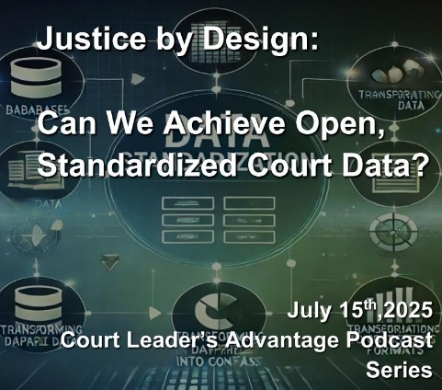
Justice by Design:
Can We Achieve Open, Standardized Court Data?
Court Leader’s Advantage Podcast Episode originally released July 15, 2025

From the Archives: We’re revisiting this important conversation about the National Open Court Data Standards (NODS) project. Although this episode was originally released in July 2025, the challenge of creating accessible, standardized court data remains just as important today.

One of the major challenges facing state trial courts today is the disturbing lack of accurate national statistical data. Beneath the surface of our justice system lies a troubling truth: we often don’t know, we can’t know, what’s really happening. How many cases do our courts handle? What kinds? How efficiently? Without reliable data, we are left to make educated guesses in the dark. This absence of clarity is not accidental, it is the result of a decentralized system of justice. Some of the results include:

Lack of Uniform Court Coding
What one court calls a “hearing,” another might call a “conference.” These differences seem small, but they add up to a patchwork of mismatched codes, formats, and definitions across jurisdictions.
Limited Data Transparency and Public Access
Even when data exists, it is often locked behind arcane systems, hard to find, and harder to interpret. Hurdles with Data Sharing
Disconnected technologies, legacy systems, and inconsistent standards create silos of information making collaboration truly a challenge.
Inability to Measure Performance and Outcomes
Without standardized metrics, we can't track how long cases take, how they’re resolved, or whether justice is truly being served. It’s like trying to navigate with a map that constantly changes shape.

Addressing this challenge is the National Open Court Data Standards project (NODS). It is a collaborative effort led by the National Center for State Courts, the Conference of State Court Administrators, and the Joint Technology Committee. By creating shared standards for collecting, sharing, and interpreting court data, NODS shines a light in the shadows, allowing courts to operate with greater transparency, efficiency, and consistency.

This month, we are looking at the National Open Court Data Standards project. We explore how this effort will transform access to court data for researchers, policymakers, the media, and the public.

Today’s Panel:

The Honorable W. Brent Powell, Judge on the Missouri Supreme Court.
T.J. BeMent, Court Administrator for the 10th Judicial District Court in Athens, Georgia
Laura Ritenour, Caseflow Management Specialist for the Administrative Office of the Courts, Phoenix, Arizona

Access the episode by going to the link on the website: https://www.nacmnet.org/podcasts
Become part of the Conversation. Submit your comments and questions to CLAPodcast@nacmnet.org

Be sure to click on the subscribe button. It draws more attention to the topic of court administration on YouTube.

