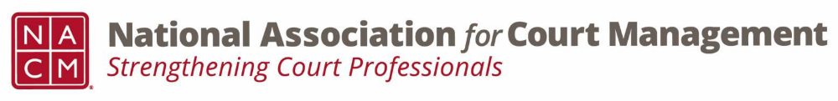
Membership Committee Meeting
Wednesday, April 8th, 2026
2:00 PM EST

We meet via Webex on the second Wednesday of each month at 2:00 PM EST
Meeting Number: 2535 534 6806
Meeting Password: YEwesC9Xn32 (93937299 when dialing from a phone or video system)
Webex Meeting Link
MINUTES
- Introduction Whitney Freese
- Membership Numbers Whitney Freese
- Subcommittee Reports
  - Early Career Professionals Erika Schmidt
  - International Krisit Cox
  - State Partnerships Tina Mattison
- Annual Award Nominations Whitney Freese
- Membership Portal Whitney Freese
  - Membership Profile
- Fireside Chats Whitney Freese
    - Tribal, Federal Courts, and Limited Jurisdiction
      - Tribal: May 22nd, 2026
      - Federal Courts: April 24th, 2026
      - Limited Jurisdiction: June 26th, 2026
- NACM Swag Storefront Update Whitney Freese

Next Meeting: May 13th, 2026

