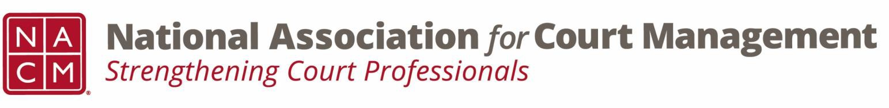

Joint Governance and DEI Committees Minutes
February 19, 2026 at 3:00 p.m. Eastern via WebEx
Governance Chair: Nicole Zoe García | DEI Committee Chair: Creadell Webb
Ethics Chair: Nate Mingo
Governance Committee Page
DEI Committee Page
- Call to Order
- January 15th Meeting Minutes Approved
- Governance Committee Updates
  - Ernie Friesen Memorial Scholarship Proposal
    - Motion to approve, no opposition, approved as drafted, present to the NACM Board.
  - Resolution Honoring Ernie Friesen
    - Motion to approve, no opposition, approved as drafted, present to the NACM Board.
  - Reporting Out from Workgroups for Community Outreach Guide
    - Groups are working on thier outreach guides.
- DEI Committee Updates
  - Discussion Topics
  - Observances
    - Lunar New Year - Lunar New Year is one of the most important annual celebrations among East and Southeast Asian cultures, including Chinese, Vietnamese and Korean communities. The Lunar New Year in 2026 is scheduled to start on Tuesday, Feb. 17, and lasts until the Lantern Festival on March 3, the date of the next full moon.
      - Some courts have put Lunar New Year Celebrations, and lists of activities on their intranet pages.
  - State of DEI
    - Update sent from Roger Rand concerning the American Federation of Teachers v Department of Education.
      - Discussion on keeping up to date with matters going on in the area of DEI, even if they’re not directly related to courts.
  - Open Discussion (e.g., DEI in your judiciary)
      - Courts are continuing with their DEI initiatives while being legally compliant. Some courts do not use the DEI acronym while others do. Some courts have focused on anti-discrimination.
- DEI Committee Site: We are always looking to add resources to our DEI Committee page: https://nacmnet.org/diversity-equity-and-inclusion-dei-committee/. Review the resources that are currently available. If you have any additional resources to share, please email those to Creadell@nacmnet.org.
- Engagement Opportunities
- Our committee is inclusive! Court professionals with a passion for diversity, equity, and inclusion may want to write articles or present. Please contact creadell@nacmnet.org or nicole@nacmnet.org if you are interested in the following:
  - Writing an article for the Court Manager
  - Writing an article for the Court Express
  - Presenting on a topic at NACM’s DEI committee
  - Presenting at a NACM conference
- Other engaging ideas are welcome!

- NACM Committee Updates
N/A

- Adjourn

