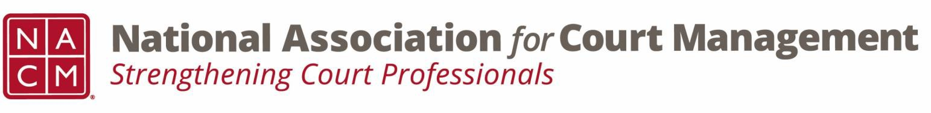

Joint Governance and DEI Committees Meeting Minutes
January 15, 2026, 3:00 p.m. Eastern via WebEx
WebEx link: https://nacourtmanagement.webex.com/nacourtmanagement/j.php?MTID=m993dd27f9bb9673cee93a56b4374fdad
Governance Chair: Nicole Zoe García | DEI Committee Chair: Creadell Webb
Ethics Chair: Nate Mingo
Governance Committee Page
DEI Committee Page
- Call to Order
- Governance Committee Updates
  - Workgroups for Community Outreach Guide
    - Leaders for each of the four workgroups were identified, and members who volunteered in the time since the last meeting were assigned as well. The groups were all instructed to have an initial meeting prior to the February meeting and to be prepared to report out at that meeting.
- DEI Committee Updates
  - Discussion Topics
  - Observances
    - Dr. Martin Luther King Jr. Holiday - The Martin Luther King, Jr. Holiday celebrates the life and legacy of a man who brought hope and healing to America. We commemorate the timeless values he taught us through his example — courage, truth, justice, compassion, dignity, humility, and service that so radiantly defined Dr. King’s character and empowered his leadership.
      - Civil Rights Movement led to the creation of the EEOC.
      - The EEOC provides guidance about workplace discrimination.
  - EEOC – DEI and Discrimination
      - Review the latest documents on the EEOC website concerning compliance with DEI programs.
  - Relevant Reports – Diversity, Equity, and Inclusion initiatives are still relevant and important in 2026. Stay up to date with trends and reports as you are developing your initiatives.
    - NCSC State of the Courts 2025 (December 10, 2025) - State of the State Courts: 2025 public opinion poll findings | National Center for State Courts
    - McKinsey & Company - Women in the Workplace (December 9, 2025) - Women in the Workplace 2025 report | McKinsey
    - Harvard Law School Forum on Corporate Governance (August 20, 2025) - DEI in Transition: 2025 Corporate Diversity Disclosure Trends
- Engagement Opportunities
- Our committee is inclusive! Court professionals with a passion for diversity, equity, and inclusion may want to write articles or present. Please contact creadell@nacmnet.org or nicole@nacmnet.org if you are interested in the following:
  - Writing an article for the Court Manager
  - Writing an article for the Court Express
  - Presenting on a topic at NACM’s DEI committee
  - Presenting at a NACM conference
  - Other engaging ideas are welcome!

- Adjourn

