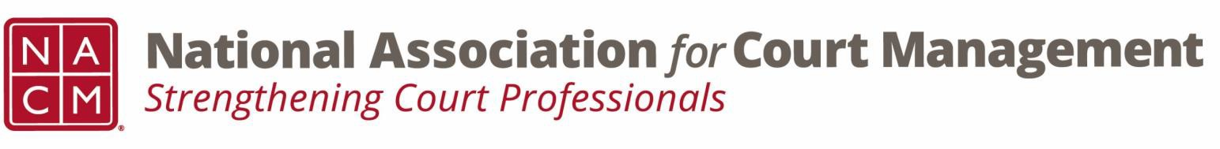

Joint Governance and DEI Committees Agenda
February 19, 2026 at 3:00 p.m. Eastern via WebEx
WebEx link: https://nacourtmanagement.webex.com/nacourtmanagement/j.php?MTID=m993dd27f9bb9673cee93a56b4374fdad
Governance Chair: Nicole Zoe García | DEI Committee Chair: Creadell Webb
Ethics Chair: Nate Mingo
Governance Committee Page
DEI Committee Page
- Call to Order
- Approval of Minutes
- Governance Committee Updates
  - Ernie Friesen Memorial Scholarship Proposal
  - Resolution Honoring Ernie Friesen
  - Reporting Out from Workgroups for Community Outreach Guide
- DEI Committee Updates
  - Discussion Topics
  - Observances
    - Lunar New Year - Lunar New Year is one of the most important annual celebrations among East and Southeast Asian cultures, including Chinese, Vietnamese and Korean communities. The Lunar New Year in 2026 is scheduled to start on Tuesday, Feb. 17, and lasts until the Lantern Festival on March 3, the date of the next full moon.
  - State of DEI
    - Update sent from Roger Rand concerning the American Federation of Teachers v Department of Education.
  - Open Discussion (e.g., DEI in your judiciary)
- DEI Committee Site: We are always looking to add resources to our DEI Committee page: https://nacmnet.org/diversity-equity-and-inclusion-dei-committee/. Review the resources that are currently available. If you have any additional resources to share, please email those to Creadell@nacmnet.org.
- Engagement Opportunities
- Our committee is inclusive! Court professionals with a passion for diversity, equity, and inclusion may want to write articles or present. Please contact creadell@nacmnet.org or nicole@nacmnet.org if you are interested in the following:
  - Writing an article for the Court Manager
  - Writing an article for the Court Express
  - Presenting on a topic at NACM’s DEI committee
  - Presenting at a NACM conference
- Other engaging ideas are welcome!

- NACM Committee Updates

- Adjourn

