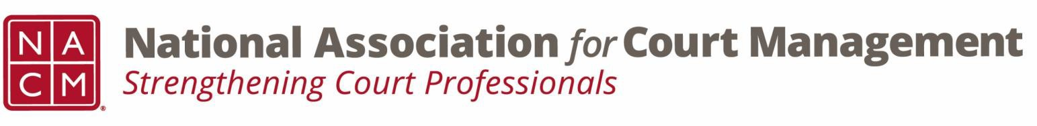

Joint Governance and DEI Committees Agenda
January 15, 2025, 3:00 p.m. Eastern via WebEx
WebEx link: https://nacourtmanagement.webex.com/nacourtmanagement/j.php?MTID=m993dd27f9bb9673cee93a56b4374fdad
Governance Chair: Nicole Zoe García | DEI Committee Chair: Creadell Webb
Ethics Chair: Nate Mingo
Governance Committee Page
DEI Committee Page
- Call to Order
- Approval of Minutes
- Governance Committee Updates
  - Workgroups for Community Outreach Guide
  - Policy for Aging Media
  - Ernie Friesen and Award of Merit
- DEI Committee Updates
  - Discussion Topics
  - Observances
    - Dr. Martin Luther King Jr. Holiday - The Martin Luther King, Jr. Holiday celebrates the life and legacy of a man who brought hope and healing to America. We commemorate the timeless values he taught us through his example — courage, truth, justice, compassion, dignity, humility, and service that so radiantly defined Dr. King’s character and empowered his leadership.
  - EEOC – DEI and Discrimination
  - Relevant Reports
    - NCSC State of the Courts 2025 (December 10, 2025) - State of the State Courts: 2025 public opinion poll findings | National Center for State Courts
    - McKinsey & Company - Women in the Workplace (December 9, 2025) - Women in the Workplace 2025 report | McKinsey
    - Harvard Law School Forum on Corporate Governance (August 20, 2025) - DEI in Transition: 2025 Corporate Diversity Disclosure Trends
  - Open Discussion (e.g., DEI in your judiciary)
- DEI Committee Site: We are always looking to add resources to our DEI Committee page: https://nacmnet.org/diversity-equity-and-inclusion-dei-committee/. Review the resources that are currently available. If you have any additional resources to share, please email those to Creadell@nacmnet.org.
- Engagement Opportunities
- Our committee is inclusive! Court professionals with a passion for diversity, equity, and inclusion may want to write articles or present. Please contact creadell@nacmnet.org or nicole@nacmnet.org if you are interested in the following:
  - Writing an article for the Court Manager
  - Writing an article for the Court Express
  - Presenting on a topic at NACM’s DEI committee
  - Presenting at a NACM conference
- Other engaging ideas are welcome!

- NACM Committee Updates

- Adjourn

