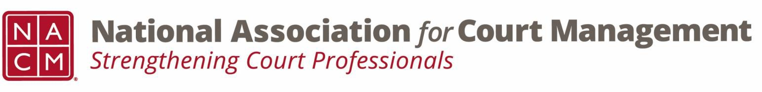

Joint Governance and DEI Committees Agenda
September 18, 2025, 3:00 p.m. Eastern via WebEx
WebEx link: https://nacourtmanagement.webex.com/nacourtmanagement/j.php?MTID=m993dd27f9bb9673cee93a56b4374fdad
Governance Chair: Nicole Zoe García | DEI Committee Chair: Creadell Webb
Ethics Chair: Nate Mingo | DEI Committee Vice Chair: Jaquetta Adewole
Governance Committee Page
DEI Committee Page
- Call to Order at 3:03pm EST
- Approval of Minutes Shirley moves to approve, Ben seconds, minutes are approved as drafted
- Business Updates
  - Governance and DEI Committees New Direction
  - Governance Projects for FY2026: the following are intended projects for the coming NACM year. If you have any interest in participating in any of these, please contact Nicole or Creadell
    - Document Management Software
    - Policy for Aging NACM Guides
    - National Agenda
    - Updating Media Guide for Courts
    - Creation of a Community Outreach and Education Guide
  - Governance Acknowledgements for FY2025: Kelsey Leggat and Craig Washburn were recognized at the 2025 Annual Conference for their contributions to the Governance committee last NACM year.
  - National Hispanic Heritage Month: Each year, Americans observe National Hispanic Heritage Month from September 15 to October 15, by celebrating the histories, cultures, and contributions of Americans whose ancestors came from Spain, Mexico, the Caribbean and Central and South America. Learn more here: https://www.hispanicheritagemonth.gov/
  - Upcoming DEI Webinar – Autism in the Courts: Building Inclusive Practices, Friday, September 19, 2025, 3:00 PM-4:00 PM. https://nacourtmanagement.webex.com/nacourtmanagement/j.php?MTID=m393d192557ede5f43497f6b70eb3b4a5
  - NACM Publications – The NACM DEI committee invites its members to write an article for the Court Manager or the Court Express. Please review a recent article by Creadell Webb titled “Artificial Intelligence: A Powerful Tool for Court Professionals” https://thecourtmanager.org/articles/artificial-intelligence-a-powerful-tool-for-court-professionals/
- NACM Committee Updates
Future of the CORE: Chaired by Greg Lambard, subgroup on tech curriculum chaired by Stacy Marks (JTC, COSCA), curricula that was removed in 2023 and we want to make sure that court leaders are trained to understand tech and the role it plays in courts.
CORE: Continuing to discuss the Champions program and how they can move forward in leadership. Also working to develop paths to join with local associations and get CORE credit for presentations done for other associations.
CORE Unleashed: Continues to go regional (Oregon and NM next in 2025). These sessions are grant funded and a good opportunity for aspiring leaders.
Website: Member portal is broken due to the company that controls our member database changed the interface mechanism and our website designer must rebuild the portal page.
Conference Development: call for proposals out for two 2026 conferences, celebrating America’s 250th birthday and preserving the rule of law
ECP: Upcoming sessions with TJ BeMent on making the leadership leap and Kelly Steele on balancing ambition with self-care
Dawn Palermo reports out on SJI grant funding, application, and how we use those funds
- Adjourn 3:53pm EST

