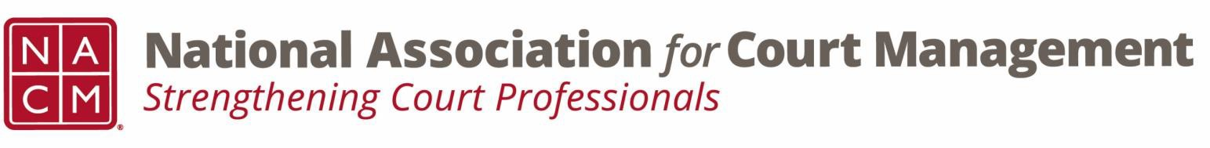

Joint Governance and DEI Committees Minutes
December 18, 2025, 3:00 p.m. Eastern via WebEx
WebEx link: https://nacourtmanagement.webex.com/nacourtmanagement/j.php?MTID=m993dd27f9bb9673cee93a56b4374fdad
Governance Chair: Nicole Zoe García | DEI Committee Chair: Creadell Webb
Ethics Chair: Nate Mingo
Governance Committee Page
DEI Committee Page
- Call to Order
- Approval of Minutes
- Governance Committee Updates
  - Workgroups for Community Outreach Guide
    - Four common themes emerged from the various goals and items that the group determined should be included in the guide. The group used this time to begin forming workgroups that will address each theme.
- DEI Committee Updates
  - Discussion Topics
  - Observances
    - Holiday Season Inclusion
      - Keep in mind that court staff celebrate a variety of holidays. Some people do not celebrate holidays at all. Find ways to be inclusive of all groups during this season. Some Courts have had “End of the Year” parties or “Dessert” parties to maintain inclusivity.
  - RECAP - IACA Presentation recap – Creadell Webb and Zenell Brown presentation on workplace inclusion.
    - Creadell Webb and Zenell Brown presented at the IACA conference in Dubai in November 2025. On a global stage, with over 50 countries represented, they presented on workplace inclusion, AI and Bias, and a tool they created called the “Court User Experience Wheel.”

