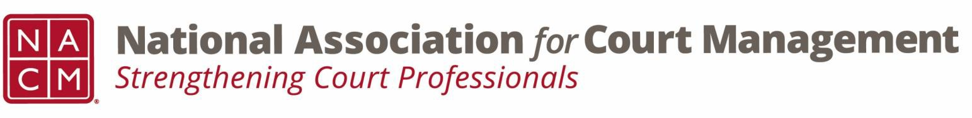

Joint Governance and DEI Committees Minutes
October 16, 2025, 3:00 p.m. Eastern via WebEx
WebEx link: https://nacourtmanagement.webex.com/nacourtmanagement/j.php?MTID=m993dd27f9bb9673cee93a56b4374fdad
Governance Chair: Nicole Zoe García | DEI Committee Chair: Creadell Webb
Ethics Chair: Nate Mingo | DEI Committee Vice Chair: Jacquetta Adewole
Governance Committee Page
DEI Committee Page
- Call to Order at 3:00 pm EST
- Approval of Minutes Tess moves to approve, John seconds, minutes are approved as drafted
- Governance Committee Updates
  - 2025 VOP (Voice of the Profession) Results
    - 15 more responses received this year than last
    - Question 10 – What do you feel NACM should focus on/advocate? (open ended question)
    - Top theme: Public Trust and Confidence – reflects the current climate
    - The court is one of the places where the public wants safety and security
    - Opened the floor for people to share their thoughts about the top themes
    - Top themes may be used to draft resolutions or articles for the Court Express or other publications
    - Workflow Management question: May open up training opportunities regarding recruitment, retaining, and onboarding staff
    - Managing bullying amongst court staff was discussed
      - Zenell shared that she will be putting on a training to discuss roles and boundaries in the workplace between judicial officers, court administrators, and court staff.
      - Peter shared that judges share differing views on administrators structure. Some prefer adminstrators report directly to them rather than to Court Executive leadership and may not value the idea of “productive pairs.”
      - Tesh noted that court staff may sometimes need to help familiarize judicial officers with certain processes, as Family Law assignments often come with limited prior experience
    - The committee agreed to organize a future panel discussion to further explore these topics
  - Governance Projects for FY 2026
    - Document Management Software
    - Policy for Aging NACM Guides
    - National Agenda
    - Updating Media Guide for Courts – The existing one needs updating
    - Creation of a Community Outreach and Education Guide – Shirley agreed to work on this
    - Those interested in assisting with any of the projects were directed to email Nicole
- DEI Committee Updates
  - Observances
  - Veterans Day – November 11, 2025: Honors all veterans whereas Memorial Day honors veterans who have died. Recognition should be inclusive to veterans and their families. Resource: Military Community at Work
  - Transgender Day of Remembrance – November 20, 2025 (resource page: FAQ: Understanding Workplace Gender Policies Under New Executive Orders
  - Best Practices for reviewing and updating your DEI programs and goals
      - Always recommends a self-audit for equity, inclusion, and diversity - Review your programs
        - Set goals that are inclusive but be careful about numeric goals
        - Office of Atty General - subject: Guidance for recipients of federal funding regarding unlawful discrimination. Identifies programs that may not receive federal funding. Instead of freezing, get a lay of the land and understand the guidance and legal pitfall and potential violations. Know where the risks are.
  - Strategic Campaign Goals
  - Engagement Opportunities
    - Writing an article for Court Manager
    - Writing an article for Court Express
    - Presenting on a topic at NACM's DEI Committee
    - Presenting on a topic at NACM Conference - proposal deadline extended to late October
    - Other ideas are welcome
  - DEI Committee page: https://nacmnet.org/diversity-equity-and-inclusion-dei-committee/. Review the resources that are currently available. If you have any additional resources to share, please email those to Creadell@nacmnet.org.
- Roundtable
  - Topic of language over competency was raised. It was suggested that training be provided in this area as it relates to assessing skills during recruitment. Things to consider: Will the potential employee be public facing, are there barriers, etc.
  - NACM Conference is being held in Albuquerque next year. Norman suggested partnering with local tribal courts and Hispanic organizations for programming content.

