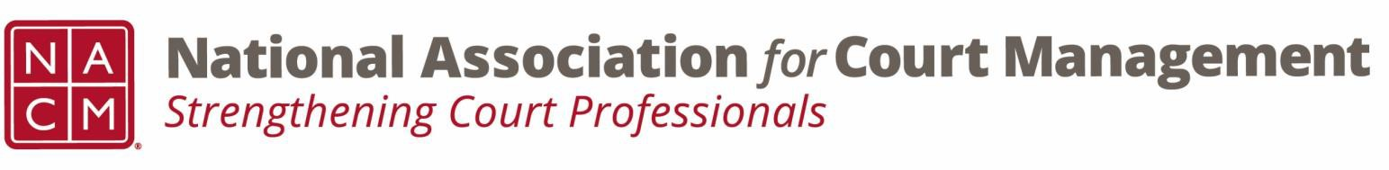

Joint Governance and DEI Committees Agenda
September 18, 2025, 3:00 p.m. Eastern via Zoom
WebEx link: https://nacourtmanagement.webex.com/nacourtmanagement/j.php?MTID=m993dd27f9bb9673cee93a56b4374fdad
Chair: Nicole Zoe García Vice Chair: Creadell Webb
Ethics Chair: Nate Mingo
Governance Committee Page
DEI Committee Page
- Call to Order
- Approval of Minutes
- Business Updates
  - Governance and DEI Committees New Direction
  - Governance Projects for FY2026
    - Document Management Software
    - Policy for Aging NACM Guides
    - National Agenda
    - Updating Media Guide for Courts
    - Creation of a Community Outreach and Education Guide
  - Governance Acknowledgements for FY2025
  - National Hispanic Heritage Month
  - Upcoming DEI Webinar
  - Court Manager
- NACM Committee Updates

- Adjourn

