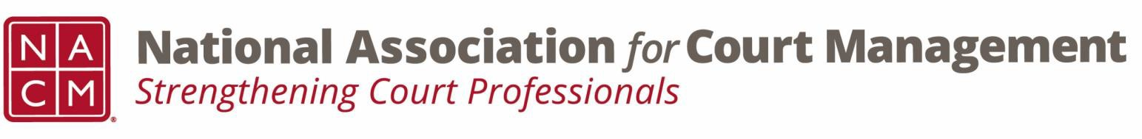

Joint Governance and DEI Committees Agenda
December 18, 2025, 3:00 p.m. Eastern via WebEx
WebEx link: https://nacourtmanagement.webex.com/nacourtmanagement/j.php?MTID=m993dd27f9bb9673cee93a56b4374fdad
Governance Chair: Nicole Zoe García | DEI Committee Chair: Creadell Webb
Ethics Chair: Nate Mingo
Governance Committee Page
DEI Committee Page
- Call to Order
- Approval of Minutes
- Governance Committee Updates
  - Workgroups for Community Outreach Guide
- DEI Committee Updates
  - Discussion Topics
  - Observances
    - Holiday Season Inclusion
  - IACA Presentation recap – Creadell Webb and Zenell Brown presentation on workplace inclusion.
  - Open Discussion (e.g., DEI in your judiciary)
- DEI Committee Site: We are always looking to add resources to our DEI Committee page: https://nacmnet.org/diversity-equity-and-inclusion-dei-committee/. Review the resources that are currently available. If you have any additional resources to share, please email those to Creadell@nacmnet.org.
- Engagement Opportunities
- Our committee is inclusive! Court professionals with a passion for diversity, equity, and inclusion may want to write articles or present. Please contact creadell@nacmnet.org or jacquetta.adewole@gmail.com if you are interested in the following:
  - Writing an article for the Court Manager
  - Writing an article for the Court Express
  - Presenting on a topic at NACM’s DEI committee
  - Presenting at a NACM conference
- Other engaging ideas are welcome!

- NACM Committee Updates

- Adjourn

