

CORE® Unleashed Program

NACM CORE® Curricula:
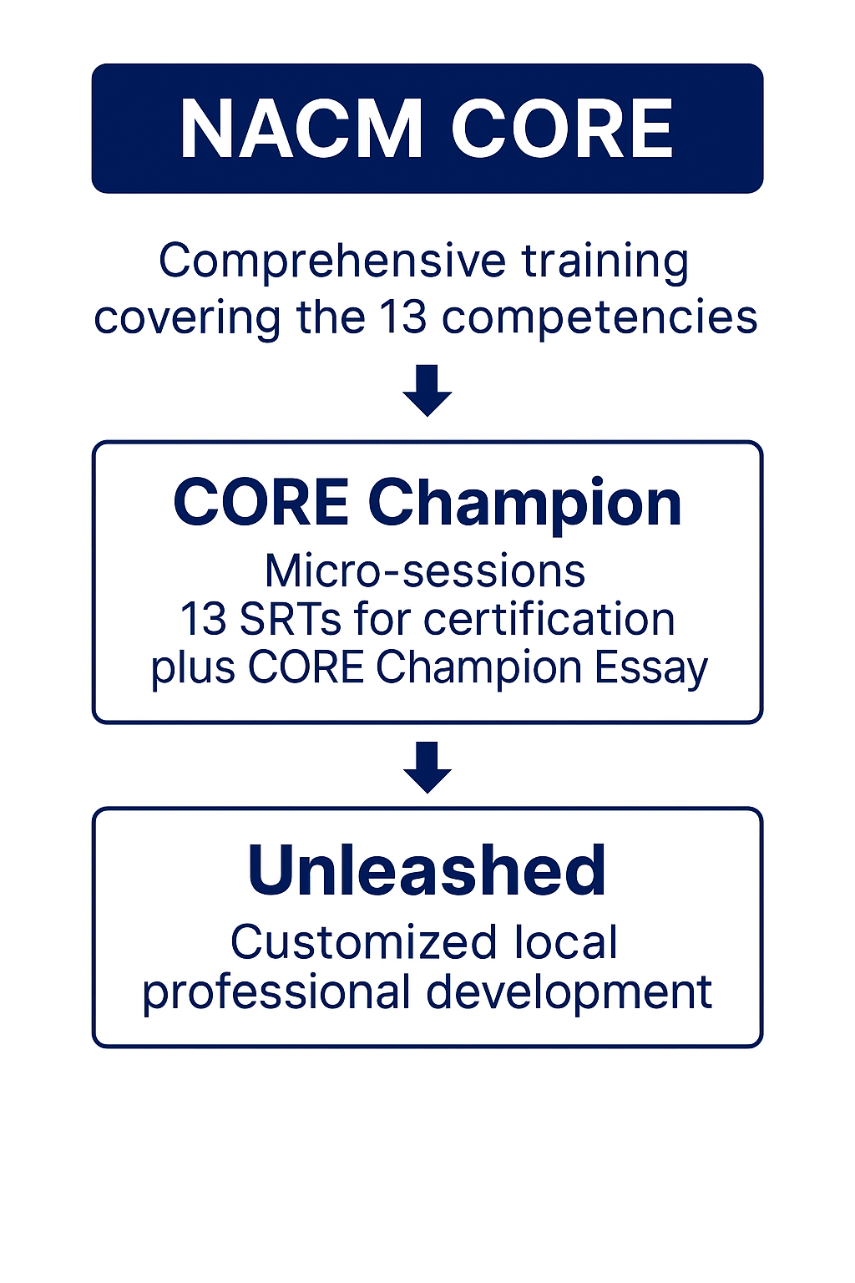
The NACM CORE® Curricula is a comprehensive training program for court leaders that covers 13 competencies core to the professional level jobs in the court profession. NACM’s intent in promoting these competencies goes beyond providing competencies for professionals working in court administration but to also promote excellence in the administration of justice and court management. The CORE® has been structured to provide consistent information across all competencies.

CORE® Unleashed Description:
The NACM CORE® Unleashed Program is a customized professional development experience based on the National Association for Court Management’s CORE®. The Unleashed Program is designed for court managers and emerging leaders, the program strengthens the knowledge, skills, and ethical foundations essential to effective court administration.

The Unleashed format can center on any combination of the 13 NACM CORE® competencies or can be the complete program (all 13 competencies). Through the build your own program option your group/organization can select which curricula you would like covered and how many days/hours you would like the presentation to be. Presenters for your program will be determined based on the selected content. All programs are designed to be interactive and participants are encouraged to share and discuss successes and challenges in their courts. These programs also qualify for the CORE® Champion Program. During the presentation sessions, participants explore real-world challenges, share experiences, and identify practical strategies for improving court operations and public service.

CORE® Unleashed Program Delivery
The sample program can span one-two consecutive training days or can be offered by two district training sessions. NACM has provided training sessions over 2 days covering all competencies, training for 2 days in one month covering 6 competencies and then returning 3 months later to cover the final 7 competencies, trained on only 3-4 competencies in 1 day and trained two different groups with the same material on two different days. The training sessions are customized to the jurisdiction and their needs. NACM is comfortable offering the same agenda to different audiences if this is the best approach for your jurisdiction. Each day requires a minimum of 50 participants if the speakers’ costs are going to be paid by the NACM grant.

CORE® Champion Certification Pathways
Participants may complete Structured Response Tests (SRTs) associated with each topic to earn credit toward the CORE® Champion Program. Successful course credit for a CORE® Competency in the CORE® Champion Program includes completing the SRT and receiving approval for the answer(s) provided in the test. Certificates Awarded:
- CORE® Explorer Certificate: Complete one competency in each module Vision, Principle, and Practice.
- CORE® Leadership: Complete all 3 competencies in the Vision module.
- CORE® Principle: Complete the 2 competencies in the Principle module.
- CORE® in Practice: Complete the 8 competencies in the Practice module.

- CORE® Champion Certificate: Complete all 13 competencies AND complete a 1-2 page essay what you learned and how it applies to your work in the court. Essays are submitted to a review committee for approval and excerpts from your essay may be published in the NACM Court Express.

Program Support & Costs
Thanks to support from NACM and the State Justice Institute (SJI):
- Speaker travel, lodging, and per diem are covered
- Program development and materials are included
The hosting court provides the training venue and audiovisual needs. Meals and beverages are not included. Some jurisdictions have ordered meals and beverages for the audience so the training could be continuous.
There is no cost to NACM Members to participate in the CORE® Champion Program.

Presenters:
Presenters will be selected upon receipt of training dates.

The CORE® Curriculum Overview:
NACM CORE® Curriculum consists of 3 modules incapsulating all 13 competencies.

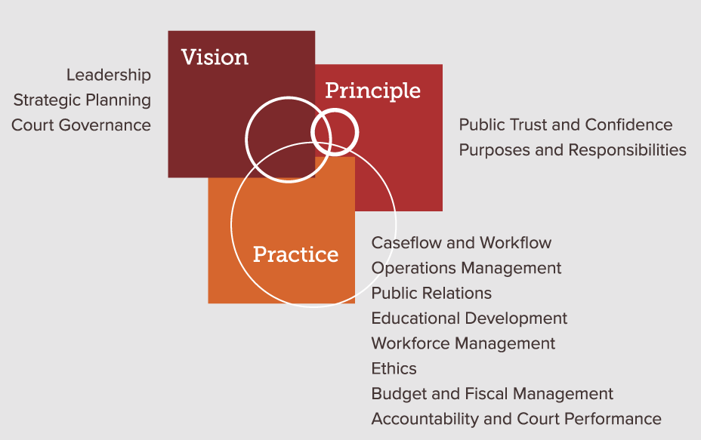
NACM and CORE® Overview (Required for all Programs)

•What is NACM and how can it benefit your group/organization
•Define what is the CORE® and how it can benefit your court
•Understand the CORE® Champion Program

Learning Objectives by Curriculum:

Public Trust and Confidence:
- Describe the importance of public trust and confidence to the credibility of judicial branch
- Identify the inherent connections between public trust and confidence and the principles of procedural fairness
- Demonstrate the ways that local courts assess public trust and confidence

Purposes and Responsibilities of Courts:
- Describe why courts exist and the major purposes that courts carry out
- Summarize the role of courts as an independent third branch of government, an institution, and an organization; and how its role impacts and complements the other two branches of government
- Articulate the practical impact and relevance of the purposes and responsibilities of courts to their jurisdiction, day-to-day court operations, and their job

Leadership:
- Understand the traits, habits, and models of leadership
- Understand the importance of leadership, credibility, trust, and ethical behaviors
- Design and foster an appropriate organizational culture that encourages and mobilizes change and engages staff

Strategic Planning:
- Identify factors that can inform and affect strategic planning processes and the implementation of strategic plans
- Encourage and foster strategic thinking and foresight in court organizations as precursors to effective strategic decision-making and strategic planning
- Recognize attributes of different court cultures and assess their potential implications for change management

Court Governance
- Define court governance principles and structure
- Identify various organization and governance models, observe and explore their own court organization, and list the inherent complexities of courts as public organizations
- Know the importance of governance and how it is needed for effective leadership

Caseflow and Workflow
- Define caseflow management and why it is important
- Identify system wide caseflow practices and court polices and evaluate strengths, weaknesses, and areas for opportunities for improvement
- Lead a learning organization by changing mindsets, mentoring staff and leading change

Operation Management:
- Recognize the role of operations management within the court organization
- Identify court operations services and programs
- Understand the various infrastructure and support needed in court organizations

Public Relations
- Understand the courts role in public relations
- Identify and recognize the challenges facing courts today in relation to its ability to discharge the constitutional mandate to uphold the rule of Law and the public’s interest in and right to information
- Understand the changing definition of media and the involvement of social media platforms

Educational Development
- Define why education is important as a tool for growth in the court system
- Identify the available resources, support, and need for educational development with the court organization
- Understand adult education principles

Workforce Management
- Define the components of workforce management
  - NOTE: Specific components of workforce management could be highlighted more in-depth during this session (onboarding, performance management, staff development, employee satisfaction, etc.)
- Identify appropriate methods and gaps in relation to workforce management with the court system

Ethics
- Define ethics and why it is important
- Identify differences in ethics codes, their own court’s code and other codes, model codes and some from specific states and courts
- Evaluate the degree of knowledge and commitment staff and court officials have toward their court’s ethics code

Budget and Fiscal Management
- Define budget and fiscal management and why it is important
- Understand basic accounting principles, how to create a budget, and develop justification for budgetary needs.

Accountability, and Court Performance:
- Define court accountability and why it is important
- Utilize court performance measurement tools and practices to identify, design, and address the effectiveness of caseflow plans, practices, and policies
- Lead a learning organization by changing mindsets, mentoring staff and leading change

Sample CORE® Unleashed Agenda

Court Management Unleashed: A Power-Packed One-Day Training

7:45 a.m. – 8:00 a.m. | Registration and Check-In
8:00 a.m. – 8:30 a.m. | Welcoming Remarks, Introduction of Presenters, & Introduction of Participants
 | Presenters Name
8:30 a.m. – 8:45 a.m. | What is NACM and What is the CORE®
 | All
8:45 a.m. – 10:15 a.m. | Leadership
 | Presenters Name
10:15 a.m. to 10:30 a.m. | Break
10:30 a.m. - 12:00 p.m. | Purposes and Responsibilities of Courts and Public Trust and Confidence
 | Presenters Name
12:00 p.m. - 1:00 p.m. | Lunch
1:00 p.m. – 2:30 p.m. | Caseflow Management, Accountability and Court Performance
 | Presenters Name
2:30 p.m. – 2:45 p.m. | Break
2:45 p.m. – 4:30 p.m. | Operations Management
 | Presenters Name
4:30 p.m. – 5:00 p.m. | Wrap-Up
 | Presenters Name
5:00 p.m. | Adjourn

Note: This example shows a jurisdiction that wanted a one-day training with only 5 competencies covered.

Sample CORE Unleashed Agenda

Court Management Unleashed: Two-Day Training
Day 1:  7:45 a.m. – 8:00 a.m. | Registration and Check-In
8:00 a.m. – 8:30 a.m. | Welcoming Remarks, Introduction of Presenters, & Introduction of Participants
 | Presenters Name
8:30 a.m. – 8:45 a.m. | What is NACM and What is the CORE®
 | All
8:45 a.m. – 10:15 a.m. | Workforce Management
 | Presenters Name
10:15 a.m. to 10:30 a.m. | Break
10:30 a.m. - 12:00 p.m. | Educational Development
 | Presenters Name
12:00 p.m. - 1:00 p.m. | Lunch

1:00 p.m. – 2:30 p.m. | Budget & Fiscal Management
 | Presenters Name
2:30 p.m. – 2:45 p.m. | Break

2:45 p.m. – 4:30 p.m. | Public Relations
 | Presenters Name

4:30 p.m. - 5:00 p.m. Wrap-Up

5:00 p.m. | Adjourn
Day 2:  9:00 a.m. – 9:15 a.m. | Thoughts in the Night/Overview of Day 1
9:15 a.m. – 10:45 a.m. | Governance
 | Presenters Name
10:15 a.m. to 10:30 a.m. | Break
10:30 a.m. - 12:00 p.m. | Public Relations
 | Presenters Name
12:00 p.m. - 1:00 p.m. | Lunch
1:00 p.m. – 2:15 p.m. | Ethics
 | Presenters Name
2:15 p.m. – 2:30 p.m. | Break
2:30 p.m. – 4:15 p.m. | Strategic Planning
 | Presenters Name
4:15 p.m. – 4:30 p.m. | Wrap-Up
This is an example of a two-day training session that is part two to a comprehensive session. The training session covers 8 competencies. The first training session covered 5 competencies so after this session participants of both training sessions will have completed all CORE Competencies.

