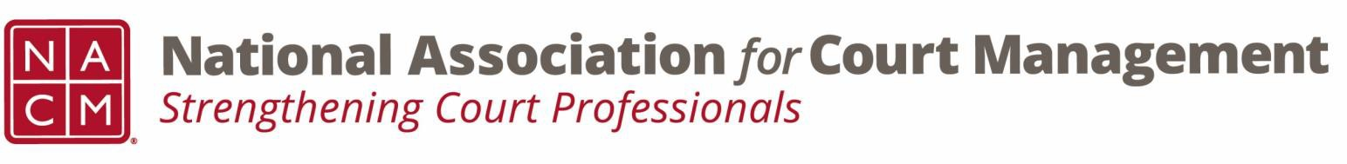

Social Media Subcommittee Meeting Agenda
October 15, 2026
Chair: Sara Miles Co-Chair: Rachel McCarthy
NACM Social Media Page

Meeting number (access code) on WEBEX: 2534 171 4651

Meeting password: cY6gn6mw4wJ

- Welcome and introductions

- Communications Committee Updates
- Meeting for Communications Committee is on Oct 22nd.

- Upcoming events, conferences, webinars, community outreach/volunteer opportunities-
  - Webinars
    - October 22 (Tyler)
    - 2nd part of Trauma Informed Courts on Oct 29
    - November (CORE)
    - December (Social Media)

  - Conferences in 2027 (La Jolla in Feb and Tacoma in July)

- Social Media content ideas
  - Feature new board members
  - Monthly post on important dates (committee meetings, webinars, etc.)
  - Promotion of the Merch Store
    - Side project of “Where in the world do they NACM?”
  - Highlighting Court Express and Court Manager
  - Mentorship program
    - Re-do video for website to also be posted on social media

- Digital standards for AI Use and Accessibility in social media
  - Discuss creating a Social Media AI protocol and WCAG practices for posts

- Standing Social Posts:
  - NOVEMBER
    - American Indian and Alaska Native Heritage Month
    - National/World Adoption Day
    - Veteran's Day
    - Transgender Day of Remembrance
    - Thanksgiving
  - DECEMBER
    - Universal Human Rights Month
    - Happy Holidays (incorporate all holidays during court recess)

NEXT MEETING IS THURSDAY, DEC 17

