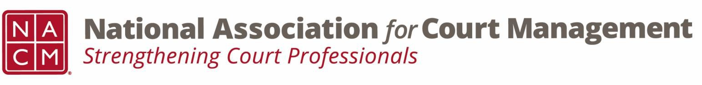

Joint Governance and DEI Committees Minutes
June 18, 2026 at 3:00 p.m. Eastern via WebEx
WebEx link: https://nacourtmanagement.webex.com/nacourtmanagement/j.php?MTID=m993dd27f9bb9673cee93a56b4374fdad
Governance Chair: Nicole Zoe García | DEI Committee Chair: Creadell Webb
Ethics Chair: Nate Mingo
Governance Committee Page
DEI Committee Page
- Call to Order: The meeting was called to order at 3:05pm ET
- Approval of Minutes: Tess moves to approve the minutes as drafted, Michele seconds. No discussion, motion carries and the minutes are approved as drafted
- Governance Committee Updates
  - General Update on Community Outreach Guide
Several groups have already turned in their drafts and Nicole will begin compiling everything after the remainder of the drafts are submitted.
  - VOP 2026 Survey Additions
Kent suggests adding a parent question of “I attended the conference” and then these questions would nest within
    - I feel this year’s conference theme is timely (yes/no)
    - I feel this year's conference theme is pertinent (yes/no)
There is discussion about the proposed question, “As a profession, I feel this has been the most impactful factor in moving the judiciary forward: (open ended response)” with the group ultimately deciding that this question needs to be rewritten for clarity.
The group votes unanimously in favor of approving the first two proposed questions. On the third proposed question, there are 4 abstentions with overall vote being in favor of adding this question.
The changes will be made to the draft VOP and submitted to the Board for final approval.
- DEI Committee Updates
  - Discussion Topics
  - July Observances
    - Independence Day/ America’s 250th – Some courts have provided employees with information about America 250 and July 4th. This may be a time to bring employees together for some history and fun.

  - Open Discussion
    - Courts are continuing their efforts to maintain far and equitable work environments. They have to be strategic with language, polices, and legal compliance.
    - Is anyone interested in a leadership role in the DEI committee, such as Vice Chair? If so, please contact us: creadell@nacmnet.org or nicole@nacmnet.org
    - Is anyone interested in taking meeting minutes for the joint Governance/DEI committee meetings? If so please contact us, creadell@nacmnet.org or nicole@nacmnet.org.
- Engagement Opportunities
- DEI Committee Site: We are always looking to add resources to our DEI Committee page: https://nacmnet.org/diversity-equity-and-inclusion-dei-committee/. Review the resources that are currently available. If you have any additional resources to share, please email those to Creadell@nacmnet.org.
- Our committee is inclusive! Court professionals with a passion for diversity, equity, and inclusion may want to write articles or present. Please contact creadell@nacmnet.org or nicole@nacmnet.org if you are interested in the following:
  - Writing an article for the Court Manager
  - Writing an article for the Court Express
  - Presenting on a topic at NACM’s DEI committee
  - Presenting at a NACM conference
- Other engaging ideas are welcome!

- NACM Committee Updates

- Adjourn 12:45pm

