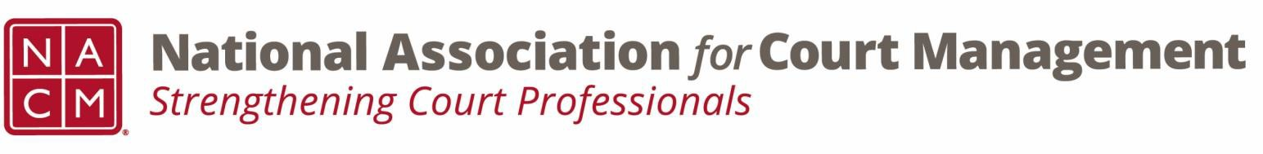

Joint Governance and DEI Committees Meeting Minutes
April 16, 2026, at 3:00 p.m. Eastern via WebEx

Governance Chair: Nicole Zoe García | DEI Committee Chair: Creadell Webb
Ethics Chair: Nate Mingo
Governance Committee Page
DEI Committee Page
- Call to Order
- Approval of Minutes
    - Meeting Minutes Approved
- Governance Committee Updates
  - Update to Article XIII of the NACM Bylaws
    - The committee voted to recommend a change to the bylaws to align with best practices for accounting. The recommendation changes the language of the bylaw to allow for a full audit of NACM financials to at least once every three years, rather than once every two years as currently prescribed. This recommendation will be posted to the membership for a final vote at the Annual Conference Business Meeting.
  - NACM Policy for Group Conference Registrations
    - The committee agreed to provide suggestions for groups sizes, discount amounts per group, and what constitutes a group. The suggestions will then be sent in a poll to the committee to vote on what the final definitions will be to send to the Board.
  - Reporting Out from Workgroups for Community Outreach Guide
    - Committee members are continuing to work on their outreach guides.
- DEI Committee Updates
  - Discussion Topics
  - Observances
    - April is designated as Autism Acceptance Month, with April 2nd, 2026, honored as Autism Acceptance Day.
Discussion of Autism Acceptance Month. Courts can provide information about autism inclusion on their intranet page, invest in training, and invest in sensory rooms.
  - DEI through the lens of the Court user experience
    - The Fairness Challenge Pilot National Report
      - Committee members were encouraged to read the Fairness Challenge Pilot Project. The fairness challenge report featured six counties in four states looking to increase fairness in their jurisdiction. These https://www.sji.gov/judicial-and-litigant-experiences-the-fairness-challenge-pilot-national-report/
  - Open Discussion (e.g., DEI in your judiciary)
- Courts are continuing with inclusive workplace initiatives. They are being
- Adjourn

