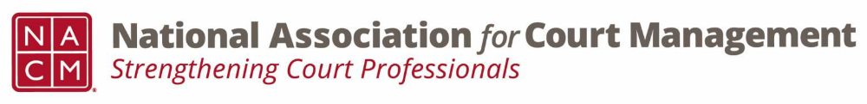
Membership Committee Meeting
Wednesday, September 9th, 2026
2:00 PM EST

We meet via Webex on the second Wednesday of each month at 2:00 PM EST
Meeting Number: 2535 534 6806
Meeting Password: YEwesC9Xn32 (93937299 when dialing from a phone or video system)
Webex Meeting Link
MINUTES
- Introduction

- Membership Numbers
  - Discount for purged members and Jacksonville attendees.
  - August 31, 2026: 1,741
  - August 31, 2025: 1,889

- Subcommittee Reports
  - Early Career Professionals Erika Schmidt
    - September 23rd at 1pm EST
    - Creating psychological safety
    - Presenters: Tess and Erika

  - International Kristi Cox
    - September 14th at 3pm EST
    - Efforts: carving out NACM’s international presence that are distinct from IACA and NCSC

  - State Partnerships Kelly Hutton
    - Next Meeting October 21, 2026 at 2 pm EST.
    - Will have Zack Zarnow from Scale Justice discussing their offerings. They are an
access to justice organization that partners with various organizations/courts and offers a various set of tools.
    - Will have open discussion each meeting for problem solving. Either for our organizations or the courts that we serve. A few topics that we will start tackling are membership engagement, right sizing the programs or services that your organization offers, and complimenting not competing with other organizations.
    - Exploring a formalized partnership with IALIS in the 2nd half of the year, once we have a check in on our bandwidth as an organization.
- Tribal Workgroup
  - Participating members have shared the goal of creating a tribal work group. Their first meeting will be sometime this month

- Merch Store Updates
  - Yeti
  - Fancy things
  - Clothing types
  - Sweater
  - NACM – Merchloop

- Membership Scholarship Updates
  - 3 recipients - already announced on social media
    - Cheyenne Garcia, Texas
    - Mark McCall, Arizona
    - Kinshasa West, Mississippi

- Membership Discounts Update
  - 20 companies listed
  - Waiting to hear back

- Mentor/Mentee Video Update
  - Need more videos
  - upload onto box
  - https://www.dropbox.com/scl/fo/boigqhscc9krixktluw1l/ANY5R7IhjYjthHeZa3g3mlg?rlkey=n67k1gqve4k45ahxt2lfdalzt&st=zj6sqhxc&dl=0

Pending projects:

- CORE Unleashed Florida
- Florida ADR Directors
- Email to Jacksonville attendees

Group Discussion
- Should a discount be offered to purged members?
- Should a discount be offered to CORE Unleashed participants?
Next Meeting: Wednesday, October 14th, 2026 at 2:00 p.m.

