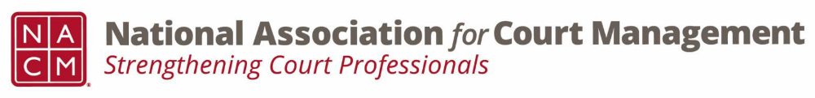
Membership Committee Meeting
Wednesday, October 12th, 2026
2:00 PM EST

We meet via Webex on the second Wednesday of each month at 2:00 PM EST
Meeting Number: 2535 534 6806
Meeting Password: YEwesC9Xn32 (93937299 when dialing from a phone or video system)
Webex Meeting Link
MINUTES
- Introduction Whitney Freese
- Membership Numbers Whitney Freese
- Subcommittee Reports
  - ECP Erika Schmidt
  - International Kristi Cox
  - State Partnerships Kelly Hutton
- Tribal Workgroup Whitney Freese
- Merch Store – Mid Year and Annual Whitney Freese
- NACM and Student Flyer Mankinta Holloway
- Membership Discounts Update Tess & Mankinta
- Mentor/Mentee Video Update Stacey Fields
- New Member Recruitment Ideas Whitney Freese
- Members on the Move Form Tess Kalicharan

Next Meeting: December 9th, 2026

