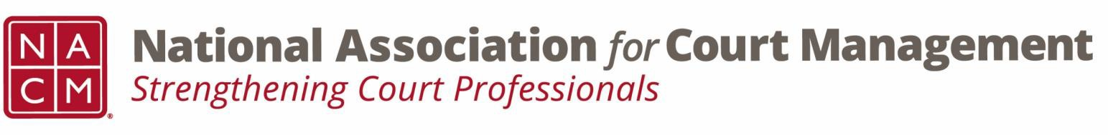

Joint Governance and DEI Committees Agenda
April 16, 2026 at 3:00 p.m. Eastern via WebEx
WebEx link: https://nacourtmanagement.webex.com/nacourtmanagement/j.php?MTID=m993dd27f9bb9673cee93a56b4374fdad
Governance Chair: Nicole Zoe García | DEI Committee Chair: Creadell Webb
Ethics Chair: Nate Mingo
Governance Committee Page
DEI Committee Page
- Call to Order
- Approval of Minutes
- Governance Committee Updates
  - Update to Article XIII of the NACM Bylaws
  - NACM Policy for Group Conference Registrations
  - Reporting Out from Workgroups for Community Outreach Guide
- DEI Committee Updates
  - Discussion Topics
  - Observances
    - April is designated as Autism Acceptance Month, with April 2nd, 2026, honored as Autism Acceptance Day. During this time, we highlight the immense contributions of autistic individuals, whose perspectives and experiences add tremendous value to society. In addition, we amplify the voices of autistic individuals, whose insights and experiences are vital to our collective growth.
  - Other Observances?
  - DEI through the lens of the Court user experience
    - The Fairness Challenge Pilot National Report
      - https://www.sji.gov/judicial-and-litigant-experiences-the-fairness-challenge-pilot-national-report/
  - Open Discussion (e.g., DEI in your judiciary)
- DEI Committee Site: We are always looking to add resources to our DEI Committee page: https://nacmnet.org/diversity-equity-and-inclusion-dei-committee/. Review the resources that are currently available. If you have any additional resources to share, please email those to Creadell@nacmnet.org.
- Engagement Opportunities
- Our committee is inclusive! Court professionals with a passion for diversity, equity, and inclusion may want to write articles or present. Please contact creadell@nacmnet.org or nicole@nacmnet.org if you are interested in the following:
  - Writing an article for the Court Manager
  - Writing an article for the Court Express
  - Presenting on a topic at NACM’s DEI committee
  - Presenting at a NACM conference
- Other engaging ideas are welcome!

- NACM Committee Updates

- Adjourn

