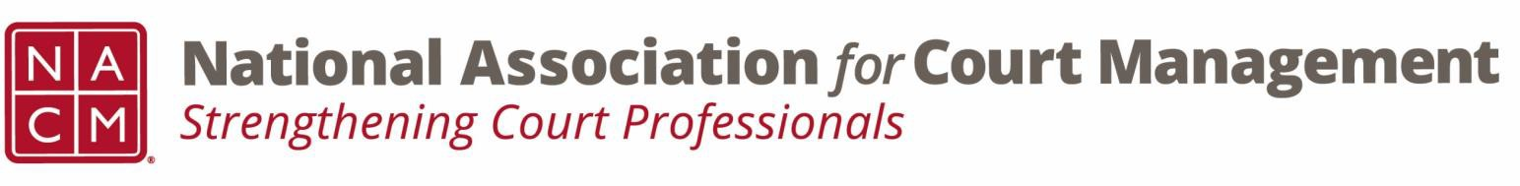

Joint Governance and DEI Committees Agenda
June 18, 2026 at 3:00 p.m. Eastern via WebEx
WebEx link: https://nacourtmanagement.webex.com/nacourtmanagement/j.php?MTID=m993dd27f9bb9673cee93a56b4374fdad
Governance Chair: Nicole Zoe García | DEI Committee Chair: Creadell Webb
Ethics Chair: Nate Mingo
Governance Committee Page
DEI Committee Page
- Call to Order
- Approval of Minutes
- Governance Committee Updates
  - General Update on Community Outreach Guide
  - VOP 2026 Survey Additions
    - I feel this year’s conference theme is timely (yes/no)
    - I feel this year's conference theme is appropriate” (yes/no)
    - As a profession, I feel this has been the most impactful factor in moving the judiciary forward: (open ended response)
- DEI Committee Updates
  - Discussion Topics
  - July Observances
    - Independence Day
    - America’s 250th
  - Open Discussion
    - Is there anything interesting going on in your courts regarding Diversity, Equity, and Inclusion?
    - Is anyone interested in a leadership role in the DEI committee, such as Vice Chair?
    - Is anyone interested in taking meeting minutes for the joint Governance/DEI committee meetings?
  - Annual Conference
- Engagement Opportunities
- DEI Committee Site: We are always looking to add resources to our DEI Committee page: https://nacmnet.org/diversity-equity-and-inclusion-dei-committee/. Review the resources that are currently available. If you have any additional resources to share, please email those to Creadell@nacmnet.org.
- Our committee is inclusive! Court professionals with a passion for diversity, equity, and inclusion may want to write articles or present. Please contact creadell@nacmnet.org or nicole@nacmnet.org if you are interested in the following:
  - Writing an article for the Court Manager
  - Writing an article for the Court Express
  - Presenting on a topic at NACM’s DEI committee
  - Presenting at a NACM conference
- Other engaging ideas are welcome!

- NACM Committee Updates

- Adjourn

