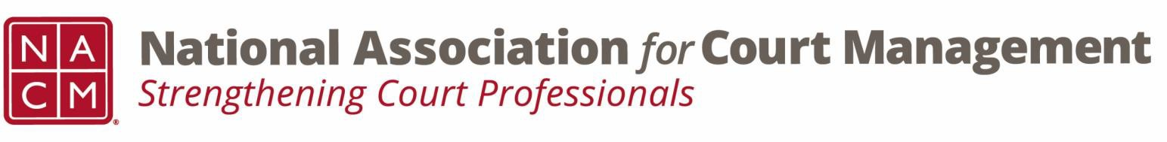

Joint Governance and DEI Committees Agenda
May 20, 2026 at 3:00 p.m. Eastern via WebEx
WebEx link: https://nacourtmanagement.webex.com/nacourtmanagement/j.php?MTID=m993dd27f9bb9673cee93a56b4374fdad
Governance Chair: Nicole Zoe García | DEI Committee Chair: Creadell Webb
Ethics Chair: Nate Mingo
Governance Committee Page
DEI Committee Page
- Call to Order
- Approval of Minutes
- Governance Committee Updates
  - General Update on Community Outreach Guide
  - VOP 2026 Survey
  - 2026 SOP
  - Discussion of Group Discounts Policy
- DEI Committee Updates
  - Discussion Topics
  - June Observances
    - Pride Month is currently celebrated each year in the month of June to honor the 1969 Stonewall Uprising in Manhattan. The Stonewall Uprising was a tipping point for the Gay Liberation Movement in the United States. In the United States the last Sunday in June was initially celebrated as "Gay Pride Day," but the actual day was flexible. In major cities across the nation the "day" soon grew to encompass a month-long series of events. Today, celebrations include pride parades, picnics, parties, workshops, symposia and concerts, and LGBTQ Pride Month events attract millions of participants around the world.
    - Juneteenth - Juneteenth, holiday observed annually on June 19, commemorating the end of slavery in the United States. A combination of the words June and nineteenth, the holiday, also called Freedom Day, has been celebrated since 1866 and is considered to be one of the oldest continuing African American holidays.
  - Status of recent DEI related cases pertaining to DEI training.
  - Open Discussion
    - September 10th webinar – Does anyone want to partner on this webinar on disability inclusion?
    - Is there anything interesting going on in your courts regarding DEI?
- Engagement Opportunities
- DEI Committee Site: We are always looking to add resources to our DEI Committee page: https://nacmnet.org/diversity-equity-and-inclusion-dei-committee/. Review the resources that are currently available. If you have any additional resources to share, please email those to Creadell@nacmnet.org.
- Our committee is inclusive! Court professionals with a passion for diversity, equity, and inclusion may want to write articles or present. Please contact creadell@nacmnet.org or nicole@nacmnet.org if you are interested in the following:
  - Writing an article for the Court Manager
  - Writing an article for the Court Express
  - Presenting on a topic at NACM’s DEI committee
  - Presenting at a NACM conference
- Other engaging ideas are welcome!

- NACM Committee Updates

- Adjourn

