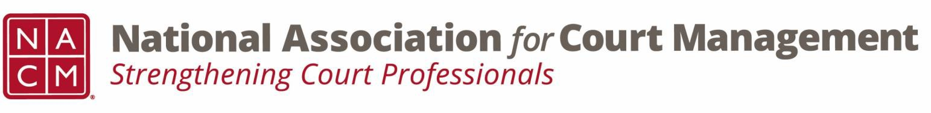

Social Media Subcommittee Meeting Agenda
August 20th, 2026

Chair: Sara Miles Co-Chair: Rachel McCarthy
NACM Social Media Page

Meeting number (access code) on WEBEX: 2534 171 4651

Meeting password: cY6gn6mw4wJ

- Welcome and introductions

- Communications Committee Updates
- Meeting for Comms Committee will be held Aug 27th.

- Upcoming events, conferences, webinars, community outreach/volunteer opportunities-
  - Webinars
    - September (DEI)
    - October (Tyler)
    - November (CORE)
    - December (Social Media)
    - NCSCJ follow up webinar October 29th at 3:00 EST

  - Conferences in 2027 (La Jolla in Feb and Tacoma in July)
    - Call for proposals recently opened

- Social Media content ideas and feedback on current posts
  - Feature on new board members
  - Highlight committees and chairs
  - Post of the webinars as they are scheduled
  - Promotion of the Merch Store
    - Side project of “Where in the world do they NACM?”
  - Highlighting Court Express and Court Manager

- Standing Social Posts:
  - SEPTEMBER
    - Constitution and Citizenship Day (SEPT 17) – Tim
    - Labor Day (SEPT 7) - Tess
    - Patriot Day (SEPT 11) - Stacey
    - Attendance Awareness Month - Erica
    - Hispanic Heritage Month - Tim
    - International Translation Day (SEPT 30) – Patrick
  - OCTOBER
- Domestic Violence Awareness Month – Erica
- Guardianship Awareness Month - Tess
- Cybersecurity Awareness Month - Rachel
- National Indigenous People’s Day (Oct 12) – Tim
- Work and Family Month - Rachel
- Mediation Week (October 18 – October 24, 2026) - Tess

NEXT MEETING IS THURSDAY OCTOBER 15

