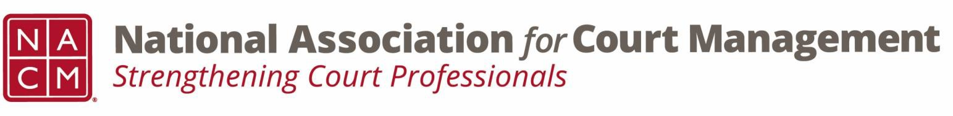

Social Media Subcommittee Meeting Agenda
August 20th, 2026

Chair: Sara Miles Co-Chair: Rachel McCarthy
NACM Social Media Page

Meeting number (access code) on WEBEX: 2534 171 4651

Meeting password: cY6gn6mw4wJ

- Welcome and introductions

- Communications Committee Updates

- Upcoming events, conferences, webinars, community outreach/volunteer opportunities-
  - Webinars
  - Conferences in 2027 (La Jolla in Feb and Tacoma in July)

- Social Media content ideas and feedback on current posts

- Standing Social Posts:
  - SEPTEMBER
    - Constitution and Citizenship Day
    - Labor Day
    - Patriot Day
    - Attendance Awareness Month
    - Hispanic Heritage Month
    - International Translation Day
  - OCTOBER
- Domestic Violence Awareness
- Guardianship Awareness Month
- Cybersecurity Awareness Month
- National Indigenous People’s Day
- Work and Family Month
- Mediation Week (3rd Week in October)

- Open Discussion

NEXT MEETING IS THURSDAY OCTOBER 15

