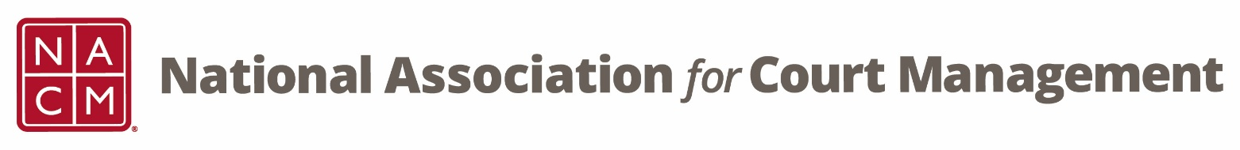
State Association and Partnership Committee Meeting
Wednesday, August 19, 2026 at 2 pm EST

Attendees:
Kelly Hutton | Tess Kalicharan | Christine Christopherson | Tim Ezell
Whitney Freese | Melinda Brooks | Andrea Strassburg | Cindy Robins
Dawn Palermo | Stacy Worby | Andrew Somers | Zach Zarnow
Creadell Webb | Kristin Schultz | Michelle Matson | Scott Mitchell
Erica Payne Santiago | Chad Weaver | Kelly Mouisset | Stacey Fields
LaShae Gilmore | Teresa Shaw | Kristi Cox | Candace Washington
Yolanda Whitlow

Minutes:
- Welcome and Introductions

- Committee Duties
Kelly Hutton reviewed the responsibilities of the committee pursuant to NACM’s Operations Manual.
- The State Association Subcommittee allows those who are state association presidents (or in leadership) to learn from one another to maintain a strong, viable association.
  - The main premise is to provide:
    - An opportunity for all state association presidents to gather at the annual conference to share ideas and educate one another
    - An opportunity to share conference speakers with one another
    - An opportunity to educate and develop leadership skills
    - Create dual membership agreements with the local association and NACM
She also indicated that for the last two years NACM has invited partner organizations to the committee meetings as well. She discussed that this has strengthened partnerships all around and lead to several great trainings.

- Goals for the Upcoming Year
The committee discussed goals for the year and what they hope that the committee will accomplish. The group discussed sharing ideas regarding:
- Attracting and retaining new members on a limited organizational budget
- Challenges facing each organization and how others can avoid the same pitfalls
- Overview of how each organization operates, what services are provided, and how to expand what is offered as a member benefit
  - Members of the committee shared services offered such as workshops, orientations, conferences, and basic court education.
- Information on staff and association turnover
- How to compliment other organizations and not compete with them and encourage sharing across the organizations
  - Members of the committee shared partnering with other organizations to distribute and share membership materials and forms.
- Having a problem-solving session on the agenda
Kelly provided general information about NACM and all of the resources that may be valuable to this group including dual-membership rates.

Creadell Webb and Dawn Palermo, chairs of the NACM CORE® Committee discussed the CORE® Curriculum, CORE® trainings, and the CORE® Champion Program.

Stacey Fields discussed the impact of NACM and her state association on her career and on the courts of Missouri specifically during funding cuts.

Kelly discussed the mutually beneficial aspects of this committee. NACM can utilize information from this committee to develop new trainings and assist in filling the gaps.

- Open Discussion/General Updates
Scott Mitchell from the National Conference of Appellate Court Clerks (NCACC) shared a list of speakers from their recent conference in Austin Texas:
- Crisis communication – Mark Weaver
- Leadership – Julie Schniers
- Courts and AI – Judge Scott Schlegel
- Self-Represented Litigants and AI – Katherine Altender Mills & Zoe Dolan

Christine Christopher shared that the National Association of State Judicial Educators (NASJE) is always open to partnerships and they collect and share webinars from all organizations. There conference will be held in Athens, GA this year.

Next Meeting will be October 21, 2026.

2026-27 Meeting dates
August 19 October 21 December 16 February 17 April 21 June 16

