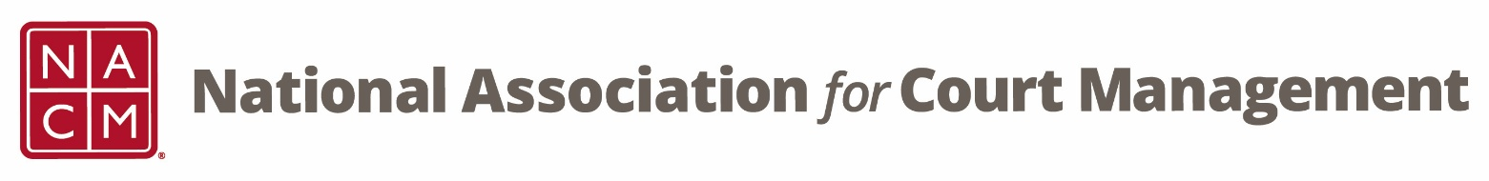
State Association and Partnership Committee Meeting
Wednesday, August 19, 2026 at 2 pm EST
WebEx Link
Meeting ID: 2536 388 4043
Meeting Password: fEPyvNXU963

Agenda:
- Welcome and Introductions

- Committee Duties

- Goals for the Upcoming Year

- Open Discussion

2026-27 Meeting dates
August 19
October 21
December 16
February 17
April 21
June 16

